WEDE5020

STUDENT NUMBER: ST10524969
  - FULL NAMES: PHILILE FAITH KHUMALO

TABLE OF CONTENTS
1. ORGANISATION OVERVIEW 2
2. WEBSITE GOALS AND OBJECTIVES 4
3. KEY PERFORMANCE INDICATORS (KPIs) 5
4. WEBSITE FEATURES AND FUNCTIONALITY 6
5. DESIGN AND USER EXPERIENCE (UX) 7
6. TECHNICAL REQUIREMENTS 11
7. TIMELINE AND MILESTONES 12
8. BUDGET 13
9. REFERENCES 14

1. ORGANISATION OVERVIEW

Field Details 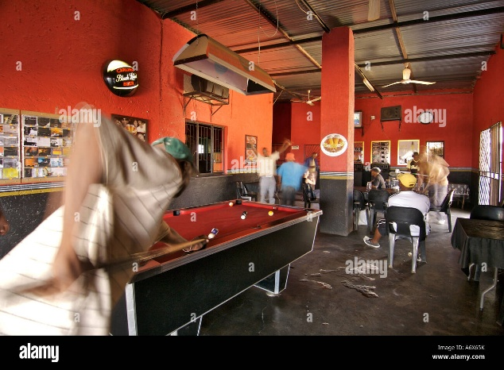
NAME: Khumalo's Tavern
Location Orlando West, Soweto, Johannesburg
Established 2015 by Thabo Khumalo
Brief History Khumalo's Tavern started as a small shebeen in Thabo Khumalo's backyard. Over the years, it has grown into a popular local spot known for its warm atmosphere, affordable drinks, and live music on weekends. It serves the Soweto community with pride, offering a safe and welcoming space for friends and family to gather.
Mission statement: To provide the Soweto community with an authentic, safe, and vibrant tavern experience that celebrates local culture, supports local suppliers, and creates jobs for youth in the area.
Vision Statement: To become Soweto's most beloved township tavern, recognised for excellent customer service, community engagement, and promoting local musicians and artists.
Target Audience - Primary: Adults aged 25–50 living in Soweto and surrounding areas who enjoy socialising after work or on weekends. - Secondary: Tourists interested in experiencing authentic Soweto nightlife and culture. - Tertiary: Local musicians and artists looking for performance venues.

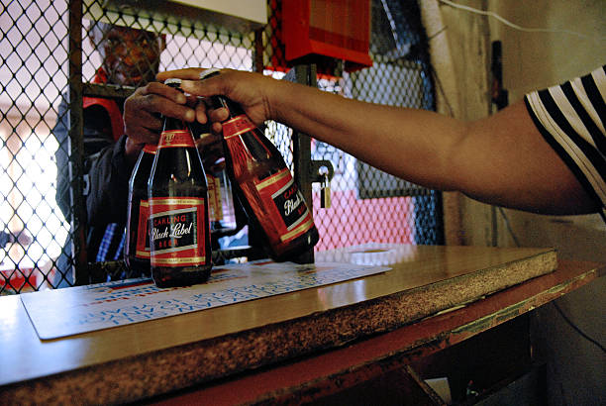

2. WEBSITE GOALS AND OBJECTIVES

Goal Objective How Website Will Achieve It
Increase brand awareness Reach 500 new local customers within 6 months SEO optimisation for local search terms like "tavern in Soweto" and "shebeen near me"
Drive foot traffic Increase weekend visitors by 30% Promote weekly events (live music, quiz nights) on the website with clear dates and times
Showcase offerings Highlight drink specials, food menu, and atmosphere Photo gallery of the venue, downloadable menu, and drink specials page
Build community Grow email/SMS subscriber list for promotions Newsletter sign-up form on homepage
Enable enquiries Make it easy for customers to ask questions Contact form and WhatsApp button integration
Support local artists Provide platform for musicians to apply to perform Online booking/enquiry form for performers.

3. KEY PERFORMANCE INDICATORS (KPIs)

KPI Target Measurement Tool
Website traffic 1,000 unique visitors/month in first 3 months Google Analytics
Contact form submissions At least 20 enquiries/month Form tracking, email records
Event page views 300 views per event listing Google Analytics
Click-to-call rate 50 clicks/month on phone number Trackable phone link
Newsletter sign-ups 100 new subscribers in 6 months Email marketing software
Bounce rate Below 50% Google Analytics
Average session duration At least 2 minutes Google Analytics

4. WEBSITE FEATURES AND FUNCTIONALITY

Page Purpose Key Content
Home (index.html) First impression; guide visitors to key areas Hero image of the tavern, welcome message, upcoming events teaser, call-to-action buttons
About (about.html) Tell Khumalo's story History, mission, values, photos of the owner and staff
Menu & Specials (menu.html) Showcase drinks and food Downloadable PDF menu, weekly drink specials, food offerings
Events (events.html) Promote live music and events Calendar of events, artist profiles, booking link for performers
Gallery (gallery.html) Visual experience Photos of the tavern, customers, live music nights
Contact (contact.html) Make it easy to find and reach Khumalo's Address, Google Map, phone number, email, contact form, WhatsApp link, operating hours

Functionality

Feature Description
Responsive design Works on mobile, tablet, and desktop (essential for customers browsing on phones)
WhatsApp integration Click-to-chat button for quick enquiries
Contact form for general questions, table bookings, or performer applications
Google Maps embed Show exact location in Soweto
Social media links Icons linking to Facebook, Instagram, TikTok
Photo gallery Lightbox-style image viewer
Event calendar Simple list or grid of upcoming events

5.DESIGN AND USER EXPERIENCE
KHUMALO’S TAVERN – SITE MAP
Primary Navigation
- HOME
- OUR MENU
- EVENTS & GALLERY
- LOCATION & CONTACT

L2: Secondary Navigation (Deep Dive)
This shows the structural breakdown and key sub-sections of those primary pages.
1. HOME (Landing Page)
- Hero Section: Primary Brand Identity/Tagline + Main CTA.
- Today’s Highlights: Quick scan of current daily food/drink specials or tonight's event.
- About Mini: Brief summary of the Tavern’s vibe and story.
2. OUR MENU
- The Grill (Braai): Listings for Shisanyama, Wors, Steaks.
- Sides & Platters: Pap, Chips, Salads, Sharing Boards.
- Cold Drinks (Beverages): Local Beers, Ciders, Spirits, Soft Drinks.
- (Optional) Digital PDF Download: A link to download the full menu.
3. EVENTS & GALLERY
- Upcoming Events: Calendar listing of live music, DJ nights, theme parties.
- The Vibe (Photo Gallery): A grid of images showing the atmosphere, food, and people.
- Social Wall: A link to, or display of, social media feed.
4. LOCATION & CONTACT
- Address/Map: Large, interactive Google Map + physical address.
- Operating Hours: Mon-Sun opening/closing times.
- Contact Info: One-click-to-call phone number, email address.
- Inquiry Form: For group bookings or private event requests.

L3: Utility Links (Global Elements)
These are links available from almost every page, usually in the footer.
- Header Button (Mobile CTA): [ Call Now] or [ View Menu ]
- Social Media Icons: Facebook, Instagram, WhatsApp Business.
- Terms of Service/Privacy Policy.

Colour Scheme
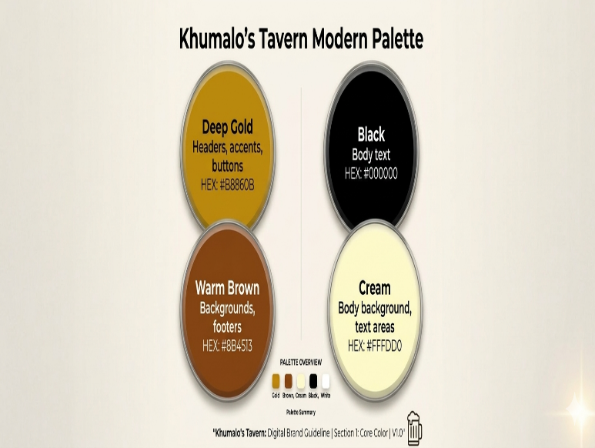
Colour Hex Code Usage
Deep Gold #B8860B Headers, accents, buttons
Warm Brown #8B4513 Backgrounds, footers
Cream #FFFDD0 Body background, text areas
Black #000000 Body text
White #FFFFFF Text on dark backgrounds

Rationale: Gold and brown reflect the warm, earthy tones of a traditional tavern – welcoming, cosy, and authentic. Cream keeps the site bright and readable.

Typography

Element Font Fallback Notes
Headings Montserrat Sans-serif Bold, modern, easy to read
Body text Open Sans Sans-serif Clean and highly readable on screens
Accents Playfair Display Serif Used sparingly for pull quotes or special text

Layout and Design Approach

· Mobile-first responsive design – Most customers will visit on phones, so the mobile experience is priority.
· Card-based layout for events and menu items – Clean and scannable.
· Large, high-quality images – Show the lively atmosphere of the tavern.
· Prominent calls-to-action – "View Menu", "See Events", "Contact Us" buttons.
· Simple navigation – Sticky header with clear menu links.

User Experience Considerations

· Fast loading – Optimise images for web.
· Easy navigation – Maximum 3 clicks to any page.
· Accessibility – Good colour contrast, alt text for images, readable font sizes.
· Clear contact info – Phone number and address visible on all pages.

Low-Fidelity Wireframes

- Top Bar: Logo and a simple “settings “cog
- Hero Section: A big search box titled with a “Check Price “button
- Status Ticker: Deep Gold bar that scrolls to update you with events.
- Action Grid: 4 large buttons for private hire, wallet, map and help
- Footer: simple icons for home , profile and history .

Homepage Wireframe

| LOGO [Home] [About] [Menu] | <-- Head>
| |
| [HERO IMAGE - Tavern Interior] |
| Welcome to Khumalo's Tavern |
| Your local spot in Soweto for great vibes |
| [View Menu] [See Events] |
| Upcoming Events |
| • Friday 13th: Live Band - The Jazzmatazz |
| • Saturday 14th: DJ Khosi |
| [View All Events] |
| Follow Us: [FB] [IG] [TikTok] |
| ©️ 2026 Khumalo's Tavern

Contact Page Wireframe:
-------------------------------------------------
| LOGO [Nav] |
-------------------------------------------------
| Contact Us |
| |
| Address: 1234 Vilakazi Street, Orlando West |
| Phone: 011 123 4567 |
| Email: khumalostavern@co.za |
| Hours: Mon-Thu 4pm-12am, Fri-Sun 12pm-2am |
| |
| [Google Map Embed] |
| |
| Name: [_THABO KHUMALO_] |
| Email: [khumalostarvern@co.za] |
| Message: [________________]
| Or WhatsApp us: [WhatsApp Button]
| Footer.

6. TECHNICAL REQUIREMENTS

Requirement Details
Domain NAME www.khumalostavern.co.za (to be registered – check availability)
Hosting GitHub Pages (free) for development; later paid hosting for custom domain and email
Programming Languages HTML5, CSS3, JavaScript (basic interactivity)
Frameworks/Libraries None required for Part 1; possible Font Awesome for icons later
Email Integration Form spree or similar for contact form (free tier)
Map Integration Google Maps Embed API
Version Control Git + GitHub (private repository)
Browser Support Chrome, Firefox, Safari, Edge (latest 2 versions)

7. TIMELINE AND MILESTONES

Milestone Description Target Date Deliverables
Part 1: Foundation
Week 1 Research and content gathering 13 March All text content collected, images sourced
Week 2 HTML structure creation 20 March 6 HTML files with basic structure and navigation
Week 3 GitHub setup and first push 22 March Repository with initial commit, README started
Part 2: Visual Design
Week 4-5 CSS styling 5 April Fully styled website with colour scheme and typography
Week 6 Responsive design 12 April Mobile-friendly layout completed
Part 3: Functionality & SEO
Week 7 JavaScript features 19 April Interactive gallery, form validation
Week 8 SEO optimisation 26 April Meta tags, alt text, sitemap.xml
Week 9 Final testing and launch 3 May Cross-browser tested, final push to GitHub
Week 10 Submission 10 May All deliverables submitted

8. BUDGET

Item Estimated Cost (ZAR) Notes
Domain Registration R150/year.co.za domain via registry.net.za
Web Hosting R0 (R500/year after GitHub Pages) GitHub Pages is free, paid hosting optional for email
Professional Email R0 (optional) Could use Gmail for now
Stock Images R0 Use Unsplashed, Pixels (free)
Icon Library R0 Font Awesome free tier
Logo Design R0 (or R500 if outsourcing) Can be created by student or client
Maintenance (Annual) R1,000 Estimated if outsourced: 2 hours/month @ R500/hour
Total First Year R15000 – R50 000 Depending on choices

Budget Justification:

· The domain is essential for a professional presence.
· Hosting can be free initially (GitHub Pages), but a paid host might be needed for e-commerce features later.
· Images and icons are available for free under Creative Commons licenses.
· Logo can be designed by the student or the tavern owner.

9. REFERENCES

Books and Articles:

· Duckett, J. (2011) HTML and CSS: Design and Build Websites. Indianapolis: John Wiley & Sons.
· Robbins, J.N. (2018) Learning Web Design: A Beginner's Guide to HTML, CSS, JavaScript, and Web Graphics. 5th end. Sebastopol: O'Reilly Media.

Online Resources:

· W3Schools (2026) HTML Tutorial. Available at: https://www.w3schools.com/html/ (Accessed: 8 March 2026).
· MDN Web Docs (2026) HTML: Hypertexts Markup Language. Available at: https://developer.mozilla.org/en-US/docs/Web/HTML (Accessed: 8 March 2026).
· Google Fonts (2026) Montserrat. Available at: https://fonts.google.com/specimen/Montserrat (Accessed: 9 March 2026).
· Unsplashed (2026) Free Images. Available at: https://unsplash.com (Accessed: 9 March 2026). [Images to be selected and cited individually later]
· Hero image: Gettyimages.com. (2026). Getty Images. [online] Available at: https://www.gettyimages.com/photos/shebeen [Accessed 10 Mar. 2026].
· Logo: Designed by [PHILILE KHUMALO] (2026).

Code References:

· W3Schools (2026) How To Create a Responsive Navigation Bar. Available at: https://www.w3schools.com/howto/howto_js_topnav_responsive.asp (Accessed: 9 March 2026). [Will adapt for this project]
· Form spree (2026) Form spree Documentation. Available at: https://formspree.io/ (Accessed: 9 March 2026).

